Electronic Supplementary Information

“Energy crisis in Europe revamps the economic competitiveness of green chemicals”

Economic assessment
We used data from process simulations to determine the energy and materials inputs and outputs as well as the necessary infrastructure associated with each production route. We then estimate the operational and capital expenditures (OPEX and CAPEX) for a reference year (2019), adjusting afterwards the results for other years using the Chemical Engineering Plant Cost Index (CEPCI) to account for inflation. For the OPEX calculations, the natural gas and electricity prices were not adjusted for inflation but instead we consider its fluctuating price at any given point in time (monthly average) based on historical market values. The hydrogen cost is considered as OPEX and estimated from the renewable electricity price and the electrolyzer cost. Fig. S1 and Fig. S2 show a graphic representation of the economic models for the estimation of production costs of fossil and green ammonia and methanol, respectively. The data used is presented in the following sections.
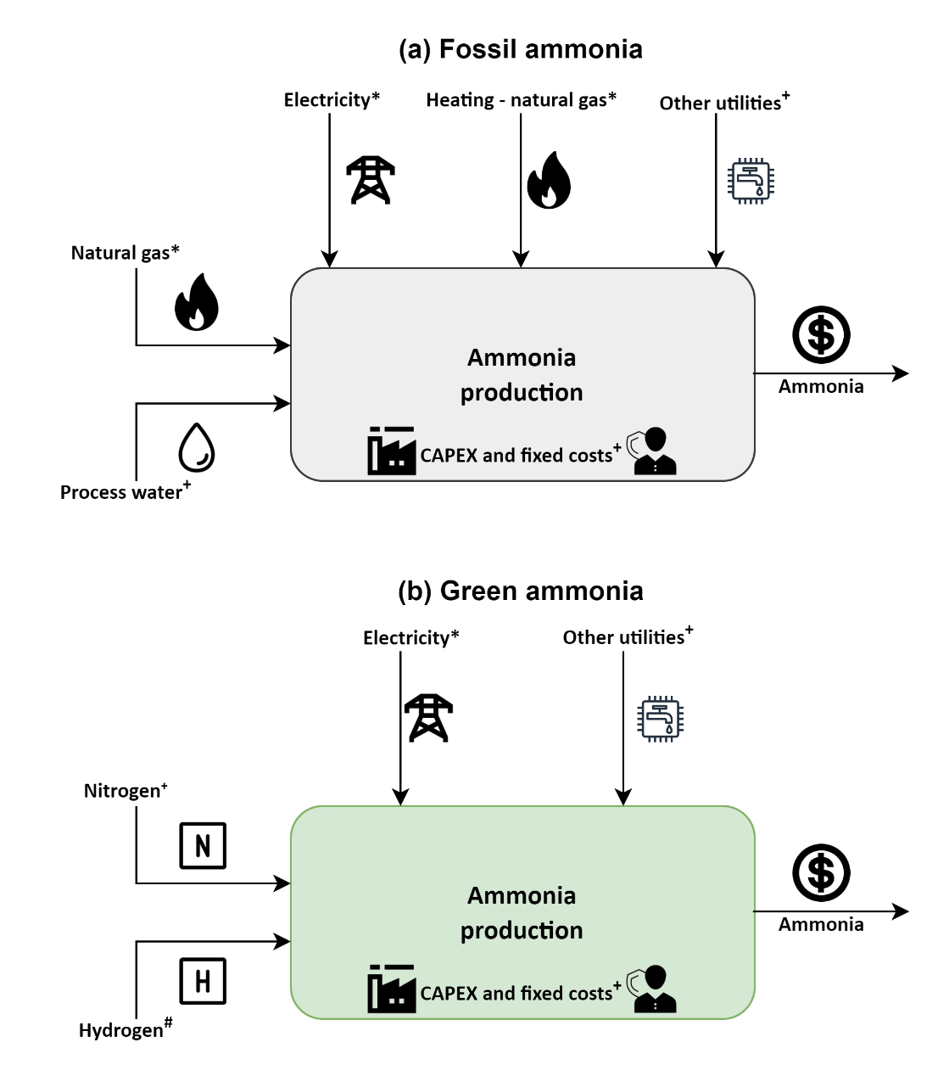
* monthly average prices
+ updated for inflation via CEPCI (prices can be found in Table S2)
# LCOH from Table S5 (for methodology refer Section S1.3)
Fig. S1. Techno-economic model for the estimation of production costs for (a) fossil ammonia and (b) green ammonia. Other utilities include cooling water, CO₂ emissions, and wastewater treatment.
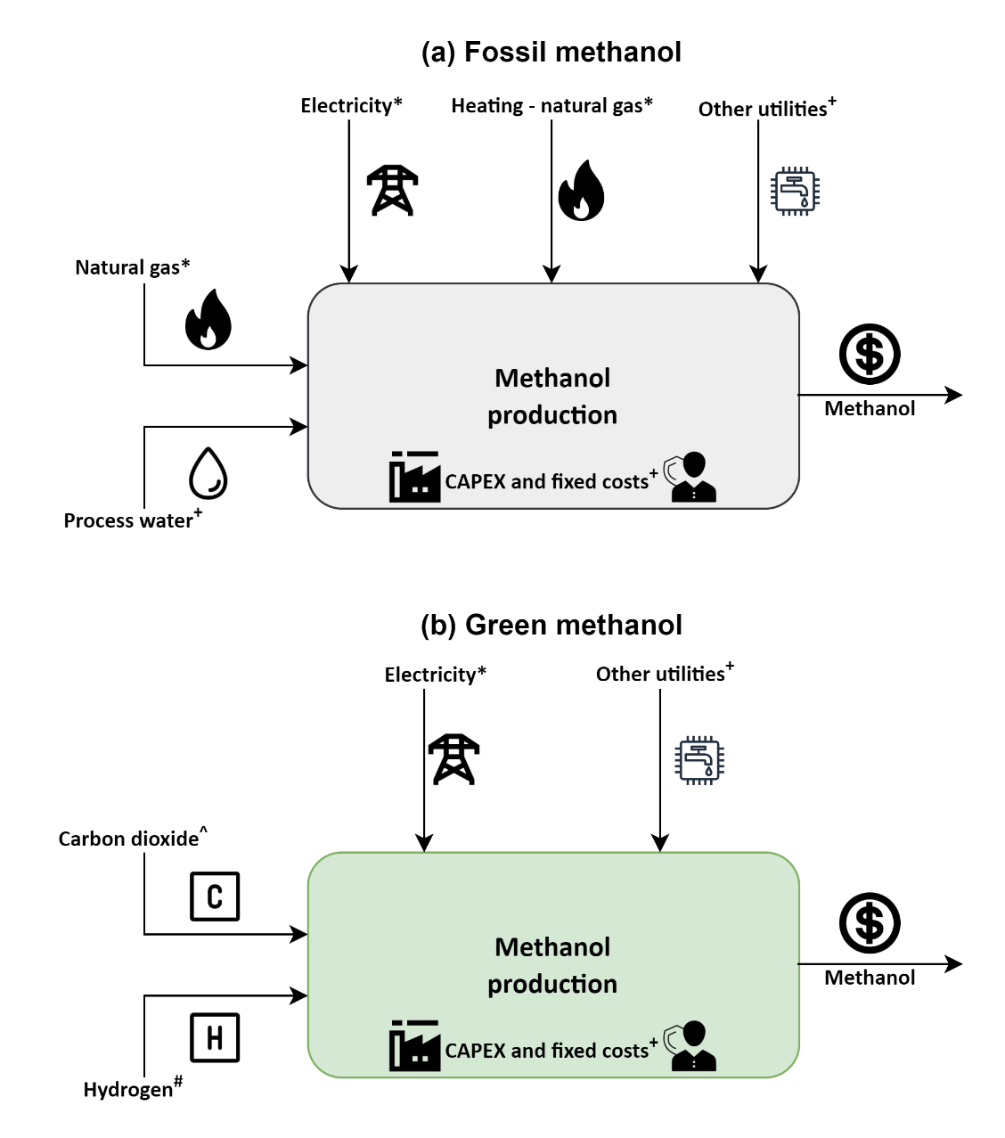
* monthly average prices
+ updated for inflation via CEPCI (prices can be found in Table S7)
# Levelized cost of hydrogen (LCOH) from Table S5 (for methodology refer Section S1.3)
^ updated with monthly average natural gas and electricity prices (see Section S1.2)
Fig. S3. Techno-economic model for the estimation of production costs for (a) fossil methanol and (b) green methanol. Other utilities include cooling water, wastewater treatment.

Energy and materials inputs and outputs
The mass and energy balances for both fossil and green ammonia are taken from D’Angelo et al.¹ and shown in Table S1. The inventories for fossil and green methanol are similarly retrieved from González-Garay et al.² and are shown in Table S2.
Table S1. Inputs and outputs of the ammonia production routes. These values are extracted from the work done by D’Angelo et al.¹.
Material/energy stream | Fossil route | Green route
Feedstock
Natural gas [t] | 0.43 | -
Process water [t] | 0.83 | -
Nitrogen [t] | - | 0.82
Hydrogen [t] | - | 0.18
Utilities
Heating – natural gas [t] | 0.10 | -
Electricity [kWh] | 935.39 | 469.89
Cooling water [GJ] | 18.12 | 3.12
CO₂ emissions [t] | 1.43 | -
Table S2. Inputs and outputs of the methanol production routes. These values are extracted from the work done by González-Garay et al.².
Material/energy stream | Fossil route | Green route
Feedstock
Natural gas [t] | 0.51 | -
Process water [t] | 0.85 | -
CO₂ feedstock [t] | - | 1.45
Hydrogen [t] | - | 0.19
Utilities
Heating – natural gas [t] | 0.15 | -
Electricity [kWh] | 74 | 300
Cooling water [GJ] | - | 4.95

Data for CAPEX calculations
XXXX. All costs have been converted to USD₂₀₂₀₋₂₂ using the CEPCI (ttttt).
Table S3. Chemical Engineering Plant Cost Index (CEPCI) from 2019 to 2022. Due to lack of availability of data, an average from January 2022 to September 2022 is considered as the CEPCI for 2022.
Year | CEPCI
2019 | 607.5
2020 | 596.2
2021 | 708.0
2022 (average till September) | 817.5

Data for OPEX calculations
The prices of feedstock and utilities other than natural gas, electricity, CO₂ feedstock, hydrogen are based on D’Angelo et al.¹ (Table XX). These prices are adjusted for inflation using the CEPCI when considering data for a different year.
Table S4. Cost parameters used in the OPEX calculations. All costs are presented in USD₂₀₁₉. These costs are further converted to USD₂₀₂₀₋₂₂ using the CEPCI.
Flow | Average | Low | High
Ammonia
Water [USD t⁻¹] | 0.18 | - | -
Cooling water [USD GJ⁻¹] | 0.38 | - | -
CO₂ emissions [USD t⁻¹] | 30 | - | -
Nitrogen [USD t⁻¹] | 91 | - | -
Methanol
Steam [USD t⁻¹] | 15.6 | - | -
Cooling water [USD m⁻³] | 0.03 | - | -
Catalyst [USD t⁻¹] | 136 | - | -
Wastewater treatment [USD m⁻³] | 1.64 | - | -
CO₂ feedstock, Direct Air Capture (DAC) [USD t⁻¹] | 137* | 68* | 207*
*These prices do not include the natural gas and electricity cost required to capture carbon dioxide.
For natural gas, we consider the monthly average spot prices at the Title Transfer Facility (TTF) hub in the Netherlands as reported in the Commodity Market Outlook of the World Bank (see Fig. 1 in the main manuscript)³. The Dutch TTF hub has gained significant importance due to its high trade volumes, and currently acts as an European and global benchmark for natural gas prices⁴. Moreover, we consider monthly average electricity prices as shown in Fig. S3⁵.
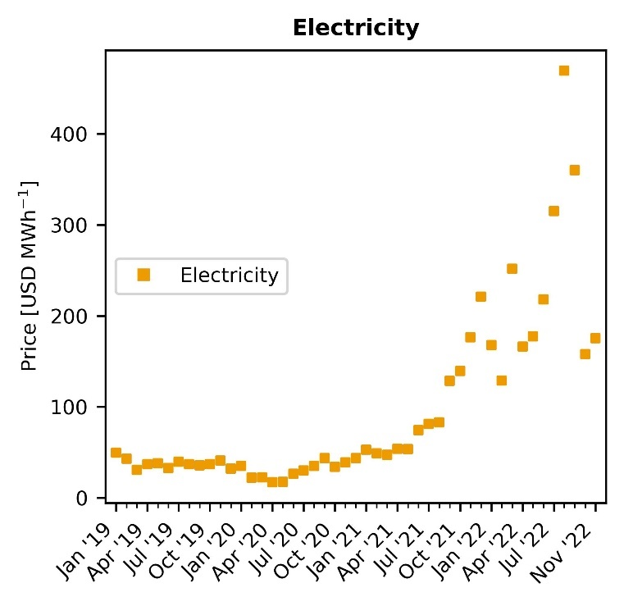
Fig. S3. Evolution of monthly average electricity prices in Europe. Notably, electricity costs per MWh increased steadily since July 2021 following similar reasons as discussed in the case of natural gas (see Fig. 1 in the main manuscript). The monthly average prices of electricity along with natural gas are used in the techno-economic models for calculating the production cost estimates.
The cost of CO₂ from Direct Air Capture (DAC) is taken from Keith et al.⁶ and updated with the new natural gas and electricity prices, thus obtaining the monthly cost shown in Fig. XX. It should be noted that the price of CO₂ capture is highly influenced by the natural gas and electricity prices as around 0.1 t of natural gas and 77 kWh of electricity is required per t of CO₂ captured.
Figure for CO2 capture cost
The levelized cost of hydrogen (LCOH) is calculated as in D’Angelo et al.¹. A Proton Exchange Membrane (PEM) electrolyzer with a stack lifetime of 60,000 hours is considered for the analysis¹. The parameters used to calculate the LCOH are shown in Table S5.
Table S5. Parameters for the Proton Exchange Membrane (PEM) electrolyzer. All values are in reference to the year 2019. These values are used to calculate the levelized cost of hydrogen using the methodology explained in Section S1.3.
Component | Value
Nominal input power [kW] | 5,000
Nominal hydrogen flow [kg hr⁻¹] | 90
Stack lifetime [hrs] | 60,000
Power demand electrolyzer [kWh Nm³_{H2}⁻¹] | 5
Capital cost [USD kW⁻¹] | 1,124
Interest rate [%] | 6.4
Other costs factor (fraction of initial CAPEX) | 0.04
Decommissioning factor (fraction of depreciable capital) | 0.10
Equipment replacement factor (fraction of initial CAPEX) | 0.15
Construction period [years] | 2
Start-up period [years] | 1
Start-capacity [%] | 50
Annual hours of operation | 8,760
First, we calculate the life span of the PEM electrolyzer using the stack lifetime and the capacity factors (Equation S1).
$$\text{Life span = }\frac{\text{stack lifetime ∙ 100}}{\text{annual hours of operation ∙ capacity factor}}$$ | (Equation S1)

The amount of hydrogen produced annually is then calculated assuming a nominal hydrogen flow per stack using Equation S2.
$$\text{Annual} {\text{H}}_{\text{2}}\text{ production =} \frac{\text{nominal }{\text{H}}_{\text{2}}\text{flow per stack }\text{∙}\text{ stack lifetime}}{\text{life span}}$$ | (Equations S2)

Assuming a start capacity of 50%, the CAPEX is estimated using the capital cost and nominal input power employing Equation S3. Notably, the capital cost is with reference to the year 2019 and is updated for inflation using the CEPCI when considering data for a different year.
$$\text{CAPEX =} \sum_{\text{i= -1}}^{\text{0}}{\frac{\text{nominal input power }\text{∙}\text{ capital cost }\text{∙} \frac{\text{start capacity}}{\text{100}}}{{\text{(1 + interest rate)}}^{\text{i}}}}$$ | (Equation S3)

The amount of hydrogen produced throughout the life span of the electrolyzer is then calculated using Equation S4. We assume that in the first year of operation the plant works at a 50% capacity. Therefore, only for the first year, the hydrogen produced is multiplied by a factor of 0.5.
$${\text{H}}_{\text{2}}\text{ produced = }\sum_{\text{i= 1}}^{\text{life span}}{\frac{\text{annual }{\text{H}}_{\text{2}}\text{production }\text{∙} {\text{H}}_{\text{2}}\text{ production capacity}}{{\text{(1 + interest rate)}}^{\text{i}}}}$$ | (Equation S4)
$$\text{with }{\text{H}}_{\text{2}}\text{ production capacity= }\left\{ \begin{aligned}\text{0.5 i} \text{=} \text{1} \\ \text{1}\text{.0}\text{ i} \text{>} \text{1}\end{aligned}\right.$$
In the next step, the total OPEX are calculated by summing the electricity costs (Equation S5) using the levelized cost of electricity (LCOE), other costs as 4% of initial CAPEX (Equation S6), plant decommissioning as 10% of initial CAPEX (Equation S7), and equipment replacement costs as 15% of depreciable CAPEX.
$$\text{Electricity cost} \text{=} \text{power demand }\text{electrolyzer} \text{∙}\text{ LCOE }\text{∙} {\text{H}}_{\text{2}}\text{ produced}$$ | (Equation S5)

$$\text{Other costs =} \sum_{\text{i= 1}}^{\text{life span}}{\frac{\text{nominal input power }\text{∙ }\text{capital cost }\text{∙}\text{ other costs factor}}{{\text{(1 + interest rate)}}^{\text{i}}}}$$ | (Equation S6)

$$\text{Plant decommissioning =} \sum_{\text{i= 1}}^{\text{life span}}{\frac{\text{nominal input power }\text{∙}\text{ capital cost }\text{∙ }\text{decommissioning factor} }{{\text{(1 + interest rate)}}^{\text{i}}}}$$ | (Equation S7)

$$\text{Equipment replacement costs} \text{=}$$  $$\sum_{\text{i= 1}}^{\text{floor(}\frac{\text{life span}}{\text{7}}\text{)}}{\frac{\text{nominal input power }\text{∙}\text{ capital cost }\text{∙ }\text{equipment replacement factor} }{{\text{(1 + interest rate)}}^{\text{i}}}}$$ | (Equation S8)

$$\text{OPEX} \text{=} \text{electricity cost} \text{+} \text{other costs} \text{+} \text{plant decommissioning} \text{+ equipment replacement costs}$$ | (Equation S9)
We retrieved European average LCOE for on-shore wind and solar electricity and their corresponding capacity factors from the International Renewable Energy Agency (IRENA)⁷ for 2019 to 2021, as shown in Table S6.
Table S6. Levelized cost of electricity (LCOE) in USD MWh⁻¹ and capacity factors (CF) in Europe.
Power technology | 2019 |  |  |  | 2020 |  |  |  | 2021
 | Avg. | Low | High | CF | Avg. | Low | High | CF | Avg. | Low | High | CF
Wind - on shore | 67 | 37 | 96 | 35.6% | 45 | 35 | 65 | 36.0% | 42 | 26 | 59 | 39.0%
Solar PV | 68 | 52 | 190 | 17.5% | 57 | 39 | 163 | 16.1% | 48 | 29 | 120 | 17.2%
In the final step, the LCOH is calculated by summing the CAPEX and OPEX and dividing by the total amount of hydrogen produced as shown in Equation S10.
$$\text{LCOH} \text{=} \frac{\text{CAPEX} \text{+} \text{OPEX}}{{\text{H}}_{\text{2}}\text{ produced}}$$ | (Equation S10)
Due to data gaps for 2022, we determine first the LCOH for 2021 and then adjust it for inflation using the CEPCI. The calculated average, low, and high LCOH for each power technology in each year is reported in Table S7

Table S7. Levelized cost of hydrogen (LCOH) in USD t⁻¹. Section S1.3 provides a comprehensive explanation of the assumptions and methodology employed for computing the LCOH values.
Power technology | 2019 |  |  | 2020 |  |  | 2021 |  |  | 2022
 | Avg. | Low | High | Avg. | Low | High | Avg. | Low | High | Avg. | Low | High
Wind - on shore | 6.88 | 5.23 | 8.48 | 5.64 | 5.09 | 6.74 | 5.38 | 4.50 | 6.31 | 6.21 | 5.19 | 7.29
Solar PV | 9.22 | 8.34 | 15.9 | 9.05 | 8.06 | 14.88 | 8.21 | 7.17 | 12.17 | 9.48 | 8.28 | 14.06

Carbon footprint assessment
The activities used from the ecoinvent v3.5⁸ database to calculate the carbon footprint are shown in Table S8.
Table S8. Inventories used from Ecoinvent v3.5 database⁸ for the background system. These activities are used to calculate the global warming potential and the avoidance costs for the different routes of production of ammonia and methanol.
Flow | Output | Activity in ecoinvent v3.5
Natural gas | Fossil ammonia and methanol, CO₂ from DAC, H₂ via SMR + CCS | natural gas production
Process water | Fossil ammonia and methanol, CO₂ from DAC | tap water production, conventional treatment
Grid electricity | All scenarios | market group for electricity, high voltage [RER]
Air separation facility | Nitrogen | air separation facility construction
Cooling water | All scenarios | water, cooling, unspecified natural origin
Solar electricity for water electrolysis | H₂ via solar | electricity production, photovoltaic, 570kWp open ground installation, multi-Si
Wind electricity for water electrolysis | H₂ via wind | electricity production, wind, >3MW turbine, onshore
Calcium carbonate for DAC technology | CO₂ from DAC | market for calcium carbonate, precipitated
Heat from steam | Non-fossil methanol | market for heat, from steam, in chemical industry
Wastewater treatment | Non-fossil methanol | market for wastewater, average

Model validation
The production cost estimates for fossil ammonia and methanol are validated with their respective market prices using the Pearson correlation coefficient (r). The production cost estimates for ammonia calculated via techno-economic models were compared with the data extracted from Green Markets® (Fig. S4). As the most reliable source for fertilizer pricing, and industry analysis, Green Markets® is a company under Bloomberg's umbrella. Green Markets® has recently published the market price of fossil ammonia from July 2019 to July 2022 for Western Europe. Fig. S4a shows the evolution of Europe's market price and production cost (estimated in this work). In Fig. S4b, we compare the two data series using the Pearson correlation coefficient (r). The r value is found to be around 0.97 showing strong correlation between the two data series.
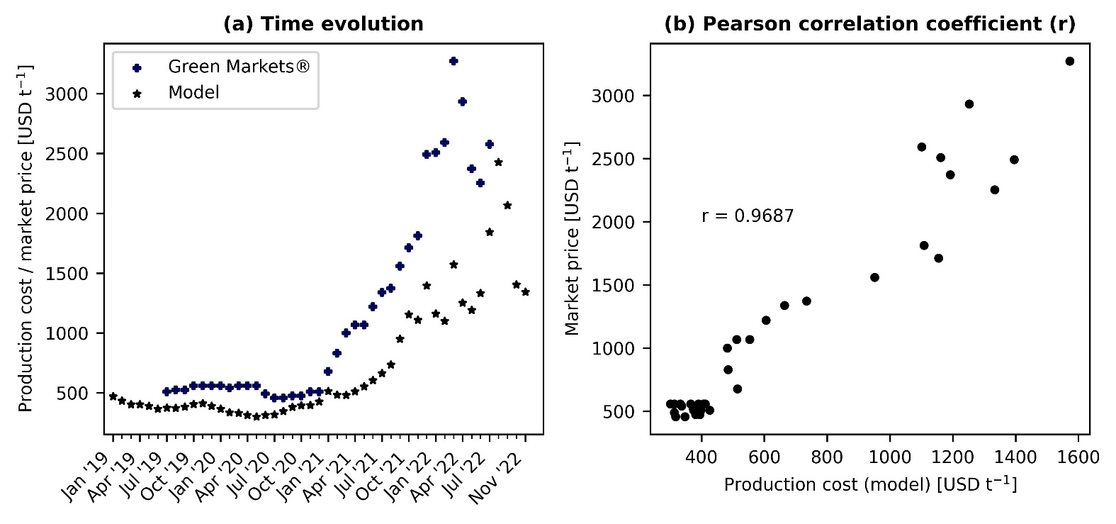
Fig. S4. Ammonia model validation. (a) shows the time evolution of the production cost estimates in comparison to the market price extracted from Green Markets®. (b) shows the correlation between the market price and the production cost estimate. A Pearson correlation coefficient (r) value of 0.97 is estimated showing strong correlations between the two data series.
Market prices for European methanol were retrieved from Methanex Corporation (January 2015 to November 2022). Methanex Corporation is the world’s largest producer and supplier of methanol to major international markets with production sites in countries like Trinidad, New Zealand, Egypt, Canada, the United States, and Chile. Similar to ammonia, the data from Methanex is used to validate our production cost estimates from January 2015 to November 2022. The evolution of Europe’s market price and estimated production cost is depicted in Fig. S5a. The r value from January 2015 to July 2021 is calculated to be around 0.75 showing a sufficient correlation between the two data series. When the r value is calculated for the entire time range (January 2015 to November 2022), the coefficient decreases to 0.68. Also, there is a visible difference between the market price and estimated production cost for fossil methanol from July 2021. This difference is thought to exist due to several reasons. On the one hand, Methanex has production sites in countries not affected by the current volatility of natural gas prices and hence produce methanol at a lower cost. When this methanol is exported to Europe, the market price is expected to be lower than the cost of production in Europe. On the other hand, we use monthly average natural gas spot prices from the TTF trading hub in the Netherlands. Companies with ongoing long-term contracts may secure a more favourable gas price compared to the current spot price, and the production cost would be lower as well. However, we would expect that the price of natural gas agreed upon in deals closed since the outbreak of the energy crisis would depend on the natural gas TTF index. Therefore, our estimates do not correspond to actual market values, but to the minimum selling prices in the market if those chemicals were produced in EU at the corresponding natural gas prices.

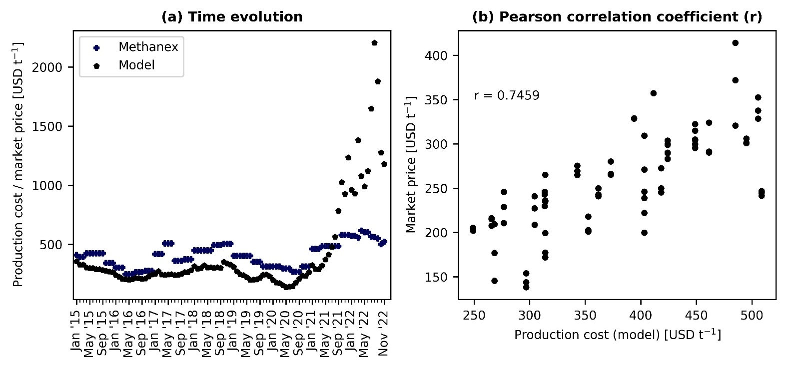
Fig. S5. Methanol model validation. (a) shows the time evolution of the production cost estimates in comparison to the market price extracted from Methanex. (b) shows the correlation between the market price and the production cost estimate. A Pearson correlation coefficient (r) value of 0.75 is estimated for the time period January 2015 to July 2021 (shown) and 0.68 for the time period January 2015 to November 2022 (not shown).

S4. Additional results
Due to space limitations, some additional results were not included in the main manuscript. Fig. S6a and Fig. S6b illustrates the cost breakdown for the production of ammonia and methanol through fossil and green routes.
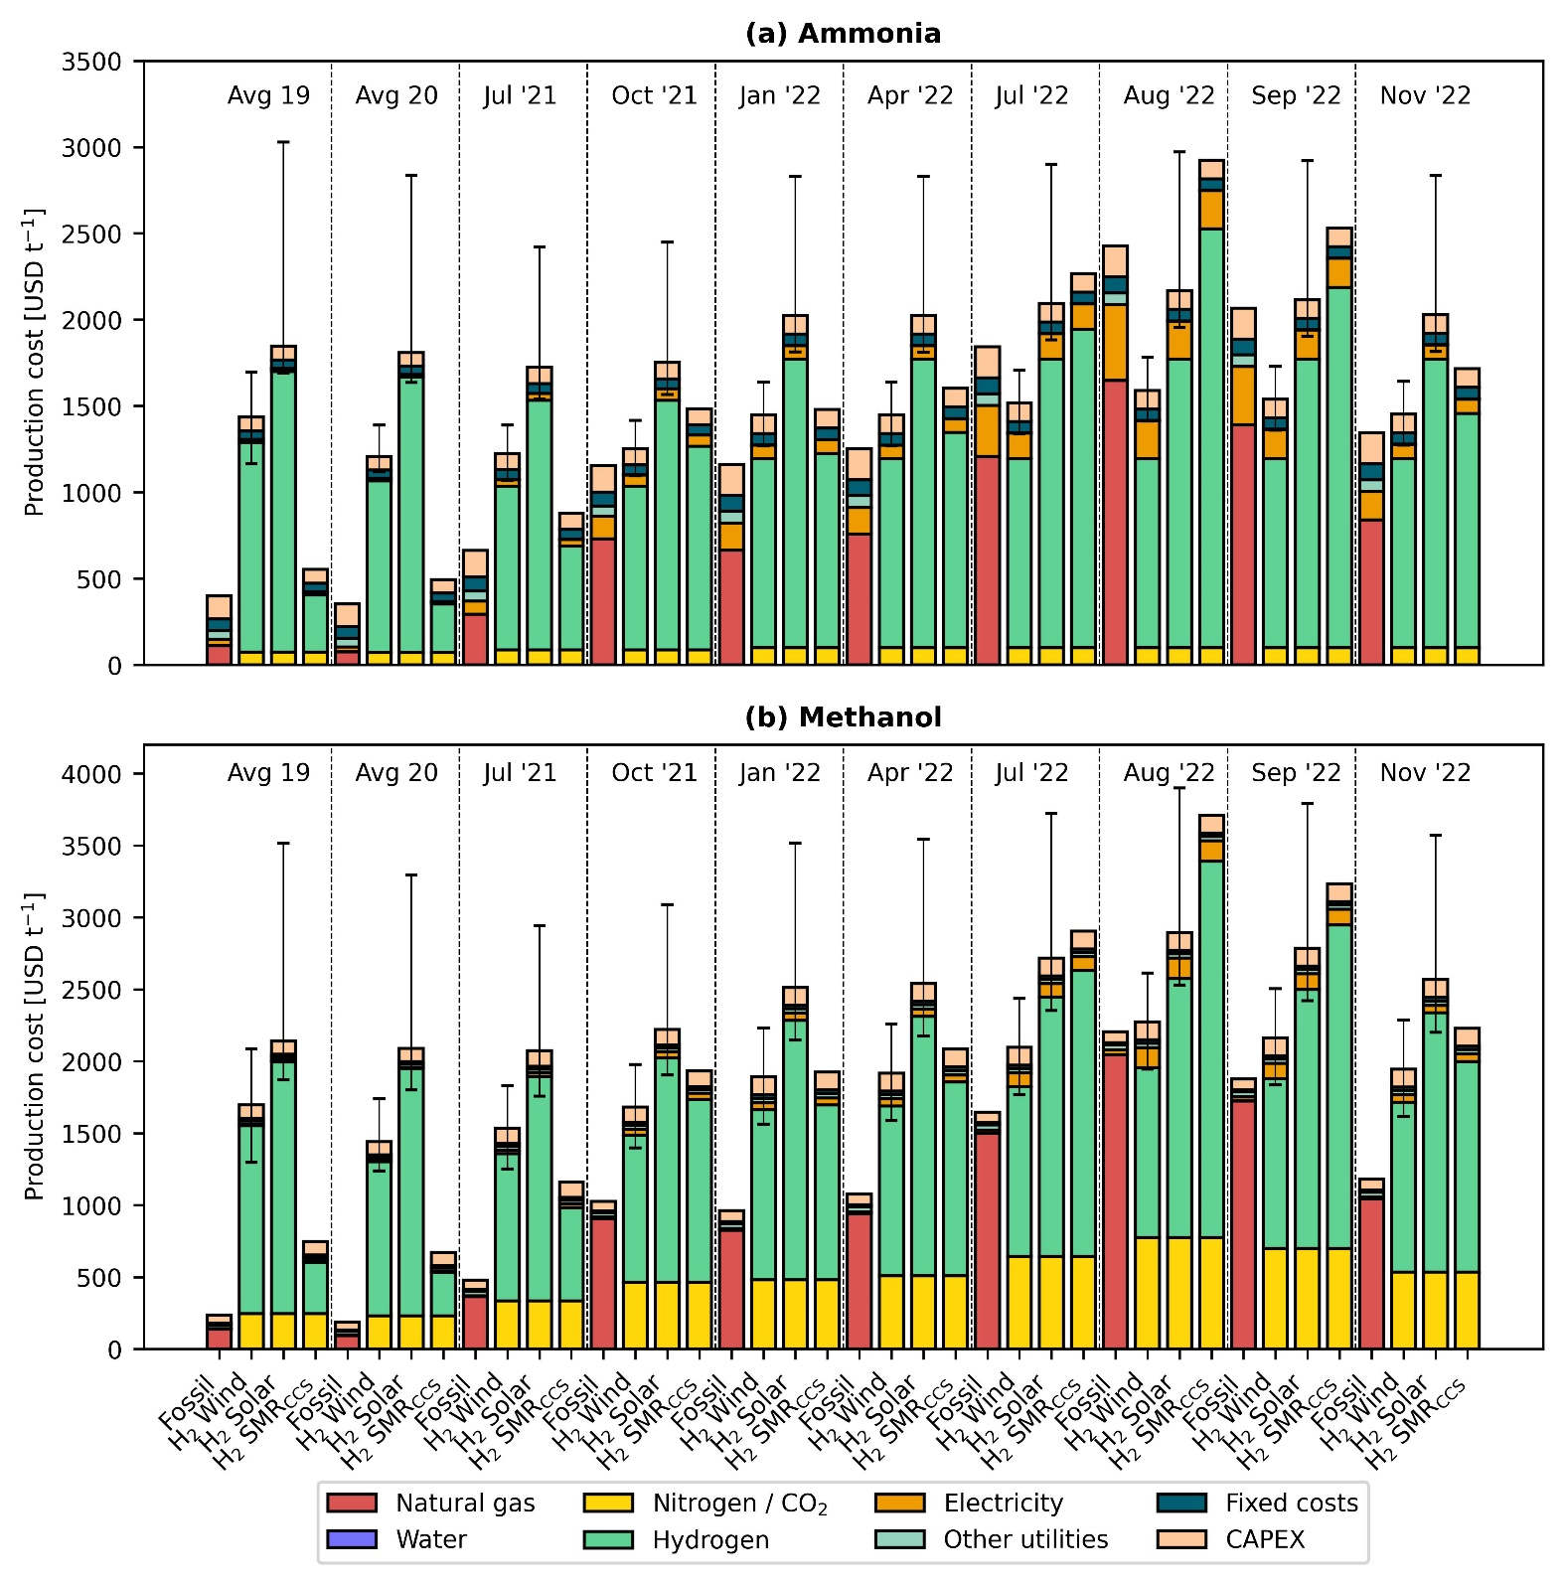
Fig. S6. Breakdown of production costs for fossil and green ammonia (a) and methanol (b). Error bars display the production cost considering the lower and upper bound for the levelized cost of hydrogen. Of all the components, hydrogen makes the greatest contribution to the average production cost of green chemicals.

References
1 S. C. D’Angelo, S. Cobo, V. Tulus, A. Nabera, A. J. Martín, J. Pérez-Ramírez and G. Guillén-Gosálbez, ACS Sustainable Chem. Eng., 2021, 9, 9740–9749.
2 A. González-Garay, M. S. Frei, A. Al-Qahtani, C. Mondelli, G. Guillén-Gosálbez and J. Pérez-Ramírez, Energy and Environmental Science, 2019, 12, 3425–3436.
3 The World Bank, Commodity Markets Outlook: The Impact of the War in Ukraine on Commodity Markets, The World Bank Group, Washington DC, 2022.
4 P. Heather, European Traded Gas Hubs: the supremacy of TTF, The Oxford Institute for Energy Studies, 2022.
5 EMBER, European power price tracker, https://ember-climate.org/data/data-tools/europe-power-prices/, (accessed February 23, 2023).
6 D. W. Keith, G. Holmes, D. St. Angelo and K. Heidel, Joule, 2018, 2, 1573–1594.
7 IRENA, Renewable power generation costs in 2021, International Renewable Energy Agency, 2021.
8 G. Wernet, C. Bauer, B. Steubing, J. Reinhard, E. Moreno-Ruiz and B. Weidema, International Journal of Life Cycle Assessment, 2016, 21, 1218–1230.

